**O. M. CHAMUDI THUSHANI** 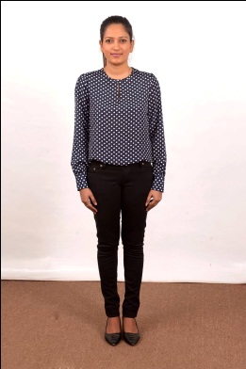

No. 66/165, Sirpentine Rd, Borella, Sri Lanka.

Tel : +94773981820 / +94112685410

E-mail : [chamudi_11@yahoo.com](mailto:chamudi_11@yahoo.com)

**Career objective**

Commencing as excellent personnel in a leading organization and use my talents to implements modest strategies to achieve its targets, devoting towards customer delightedness by creating competitive advantages while securing inside the organization.

**personal details**

**Full Name** : Owita Mullage Chamudi Thushani

**Address** : No: 66/165, Sirpentine Rd, Borella Colombo-08

**N.I.C No** : 915112773 V

**Date of Birth** : 11th January 1991

**Age** : 24

**Gender** : Female

**Civil Status** : Single

**School Attended** : Gothami Balika Vidyalaya, Cololmbo-10

**academic qualification**

* I have completed a Diploma in Information technology in Science Land **(SLIT)**

* I have followed a Business management course in British Colombia Computer Academy **(BCCA)**
* Passed G.C.E. Advanced level examination in 2009

Economics S

Business Studies S

Accountancy S

General English S

* Passed G.C.E. Ordinary level examination in 2006

Buddhism A Social Studies C

Mathematics B Health Science C

English B Science S

Commerce B Art S

Sinhala C

**professional qualification**

* I have worked as a Student Bank Co-coordinator in School Peoples Bank branch (Peoples Bank suduwella branch)

**extra curriculer activities**

* A member of Sri Lanka youth association
* A member of school media circle
* A member of Campbell net ball association
* School senior House captain in 2006
* School net ball team captain in 2004, 2005 & 2006
* Have been a player of school hockey team, volley ball team & athletic team
* Worked as a Student Bank Co-coordinator in School Peoples Bank branch

**working experience**

**01 Designation Heavy Equipment Officer**

**Company Keangnam Enterprises Limited,**

No. 815, E.W. Perera mawatha, Ethull Kotte, Sri Jayawardanapura, Sri Lanka.

**Duration** 11thMay 2011 to date

**Job Description** I**.** Handling Keangnam Heavy Equipment

Management System (Database Program)

II. Vehicle registration for all new or

re-condition un-registered auto

mobile vehicles, RMV duties Including

Transfer ownership & Registration &

cancellation etc.

III. Handling vehicle revenue license & vehicle

Non-user certificates

IV. Purchasing & ordering vehicles and spare

parts by locally & overseas.

V. Handling Motor, plant & machinery

Insurance.

VI. Preparing reports and other

correspondence to report local and

overseas management.

**NON-RELATED REFEREES**

1. **Mr. Dayananda Hennayake**

Project Manager

Keangnam Enterprises Ltd.

No.815,

E.W.Perera Mawatha,

Ethulkotte.

011-2876001~5, 0773-207566

1. **Mr. Dumeen Abeywikrema**

Head of IT

Premio (pvt) Ltd.

48/2 Wanawasala Road

Kelaniya

011-2856809, 0778-568038

Thank You,

Yours Truly,

.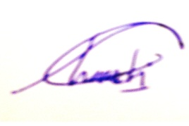

O.M.C.Thushani